**Střední průmyslová škola elektrotechnická, Praha 2, Ječná 30**

**Informační technologie**

**Ječná 30, 120 00, Praha 2**



**Image to ASCII**

https://github.com/DimcikUwU/imgToASCII.git

**Dmytriy Ilkov**

**IT**

**2022**

⦁ **Cíl práce**

Write the most basic image to ASCII convertor

⦁ **Software**

IntelliJ IDEA Community Edition

⦁ **Program**

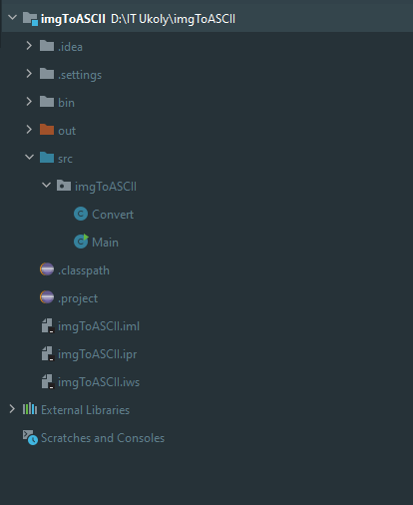

⦁ **Závěr**

I tried to do this the easiest way possible and with my friends help it was easier than i thought, but again its the most basic one so its not perfect. In my opinion it still looks good. There was a lot of stuggle but i somehow made it. I dont want java anymore please. Overall it was a fun project. :)